Valance Chart Review

Looks to me like things continue to modestly improve with the first three quarters of this year showing sequential improvement.
Good for corporate earnings, not so good for people in general.

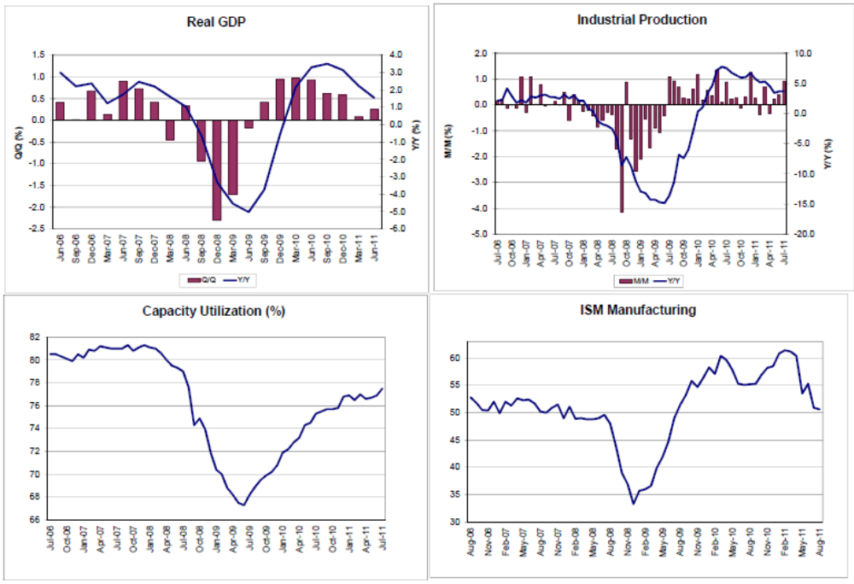
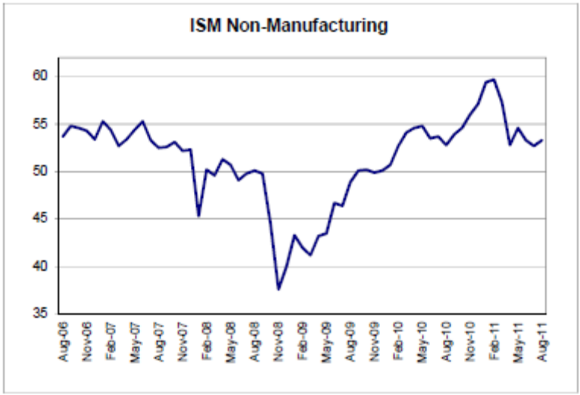
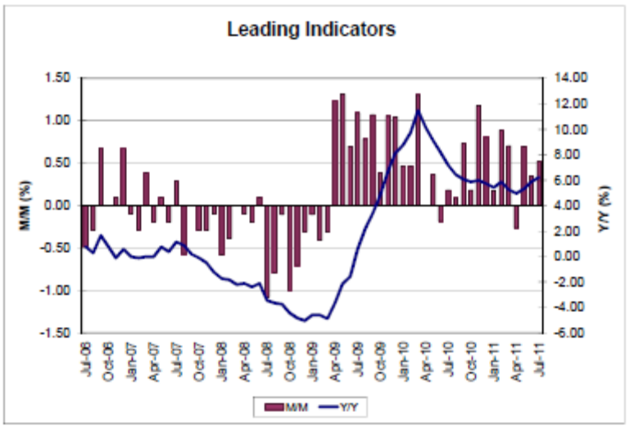
Q3 GDP forecast at about +2%, manufacturing and non-manufacturing still modestly improving after a smallish bounce from the bottom of the recession.
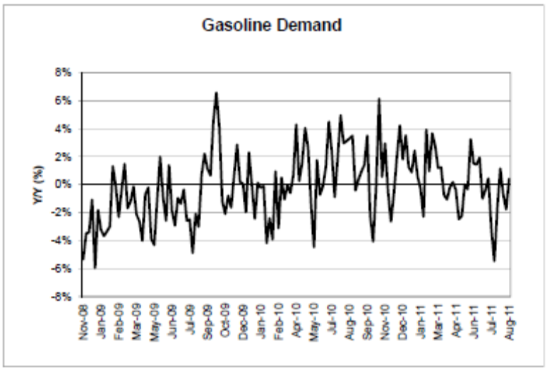
This indicator continues to be relatively tame as well.

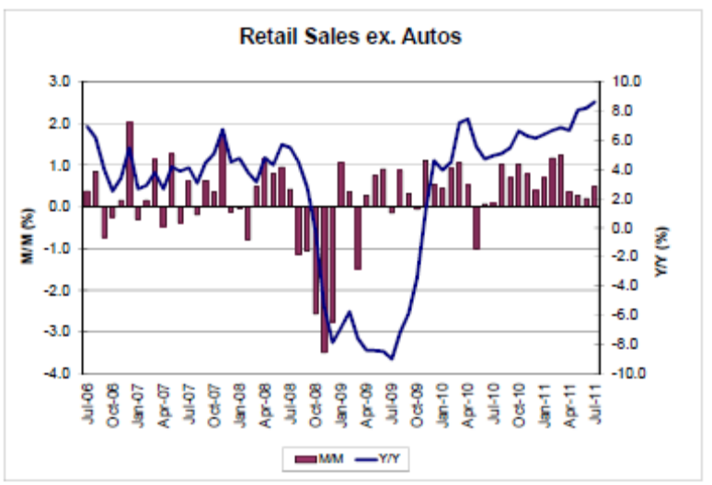

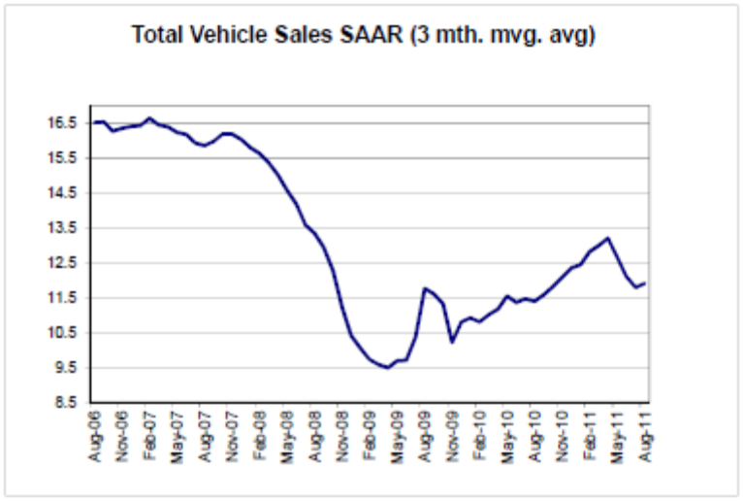
Retail sales modestly improving, and after taking a breather from the earthquake, car sales are starting to head back to where they were.

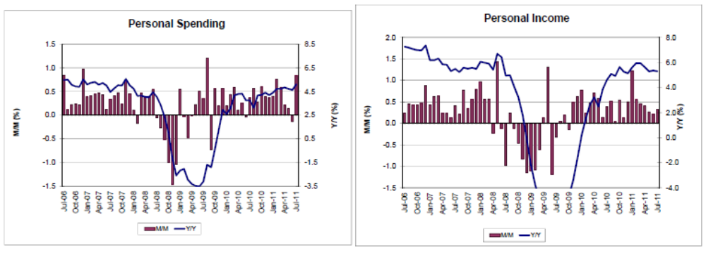
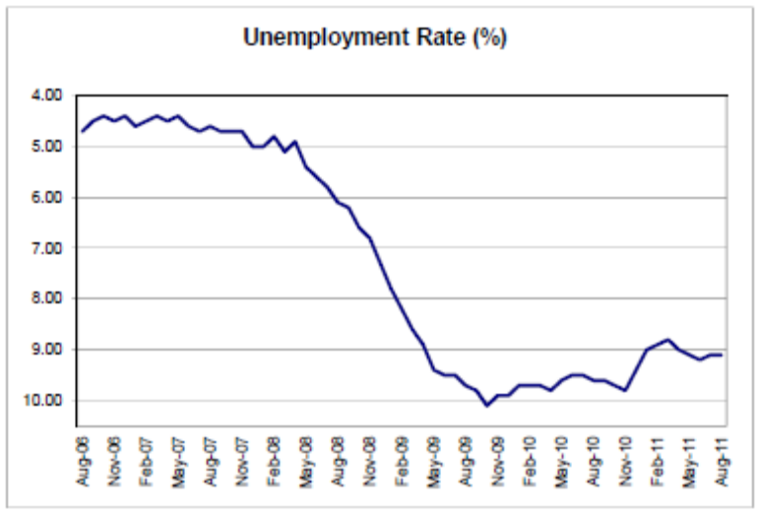
Modest improvement

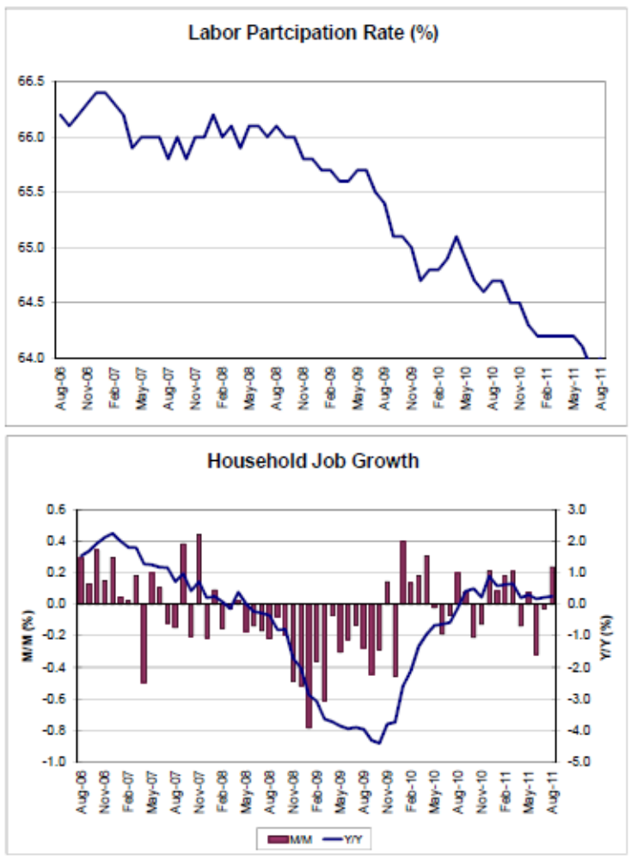
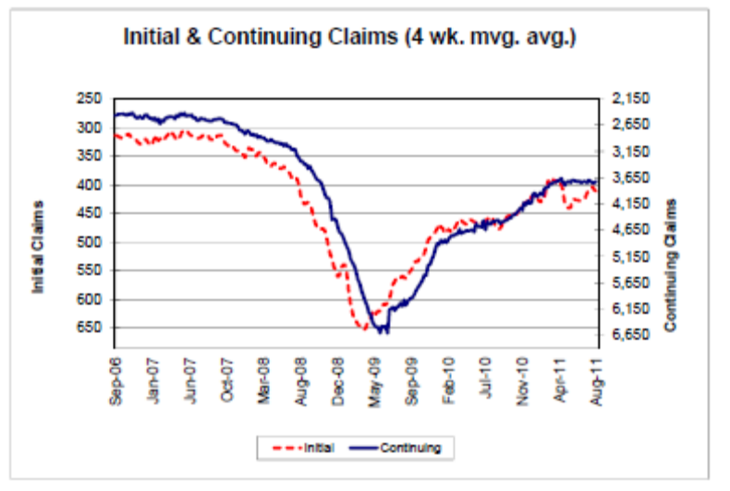
Some job growth but not keeping up with the population growth due to the continued real wealth reducing shortfall of aggregate demand.

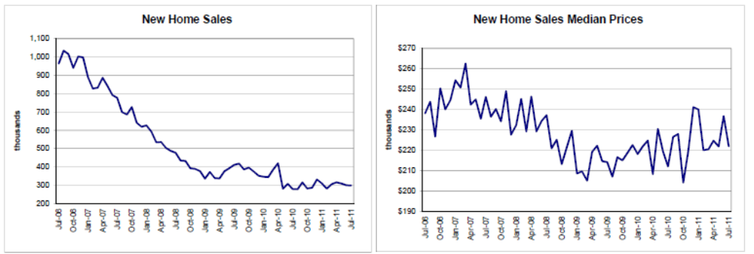
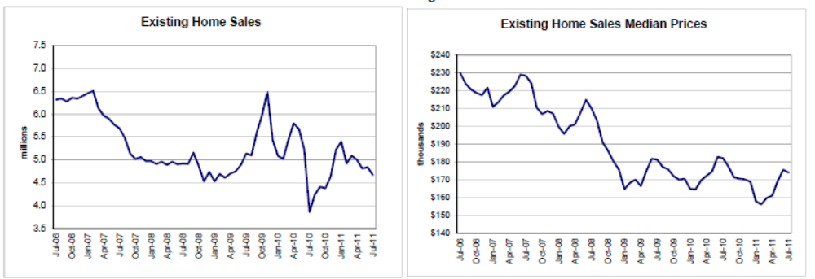
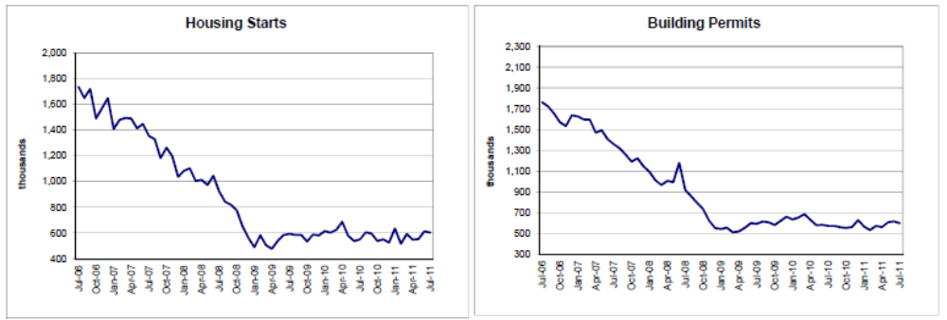
Housing continues to look very L shaped as well.

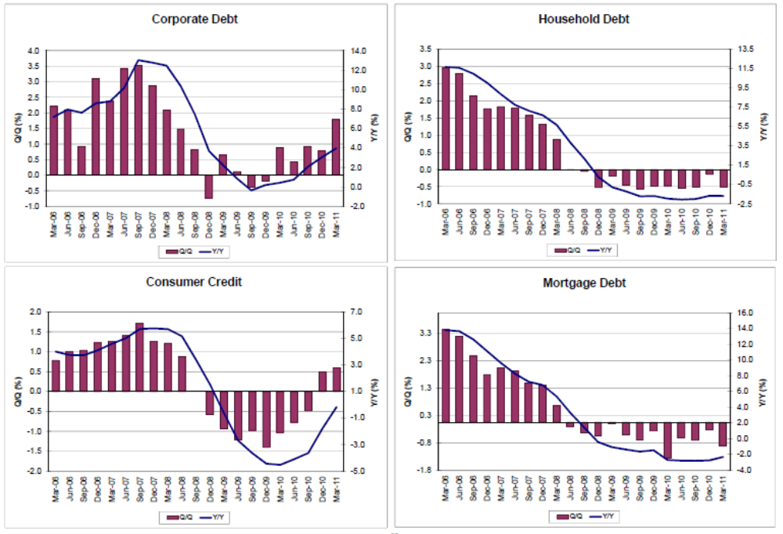
Nothing exciting happening here.
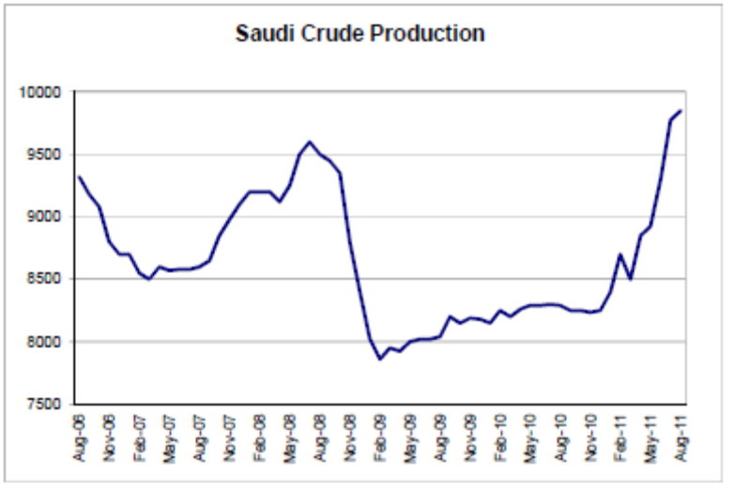
The Saudis, as swing producer/price setter, have made up for the drop in supply from Lybia.
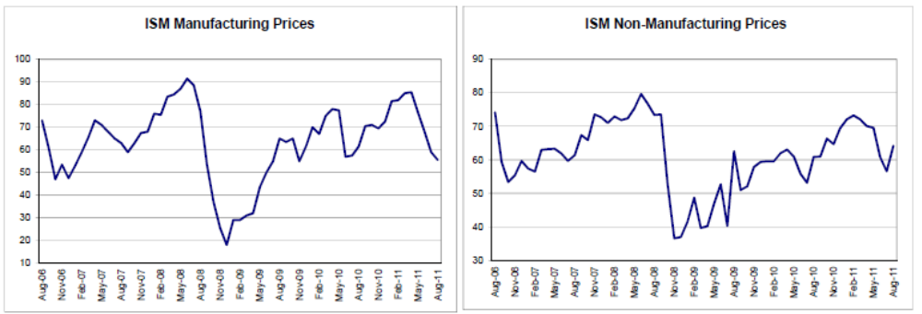
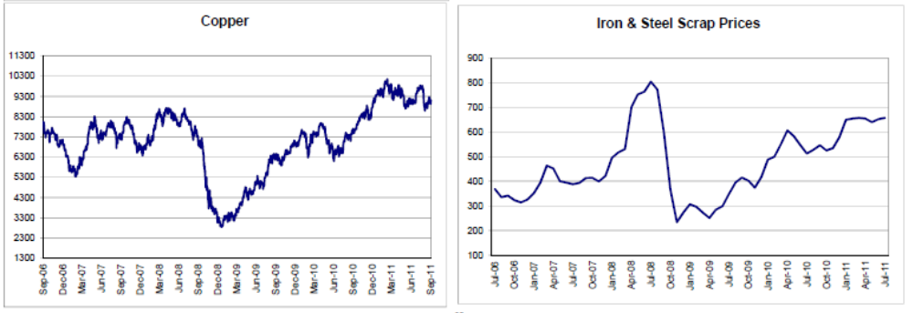
Moderation on the price side as crude oil prices and demand growth eased some.
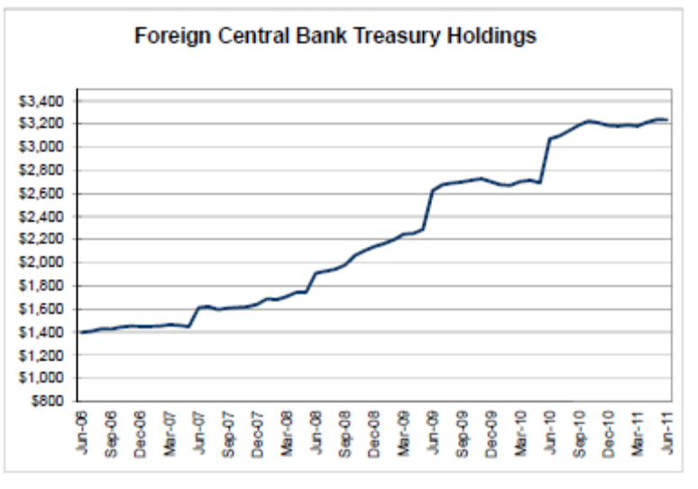
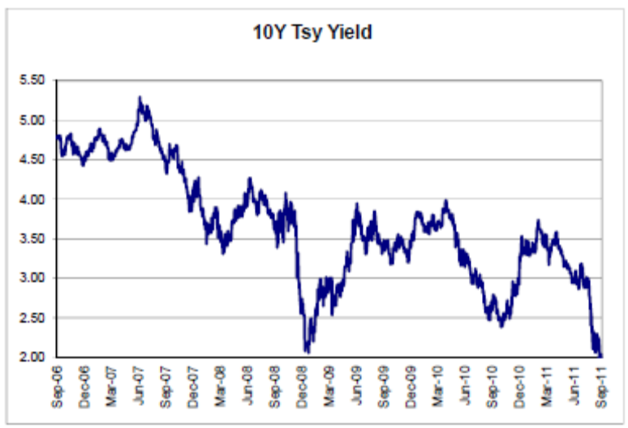
Tsy yields down without much new CB or Fed buying
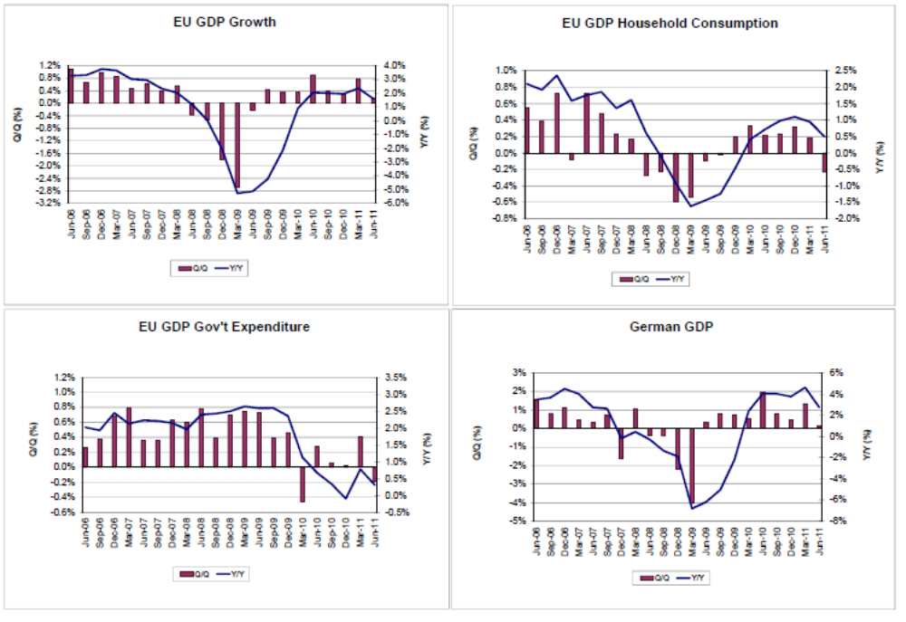
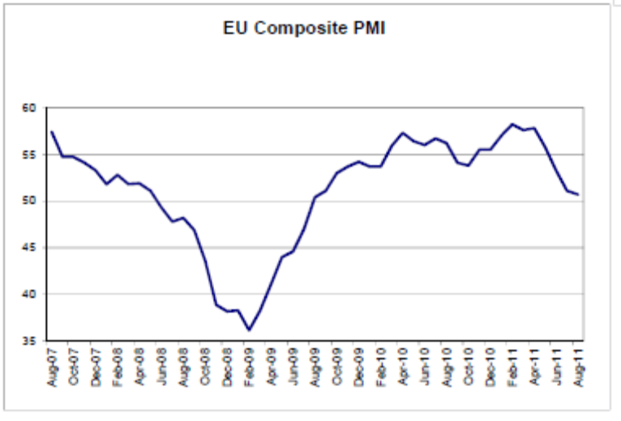
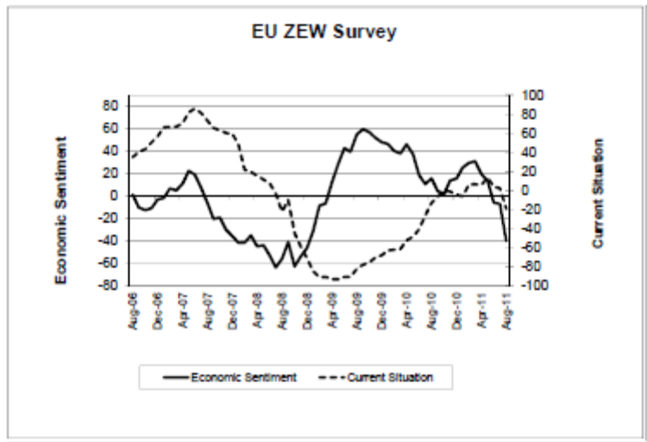
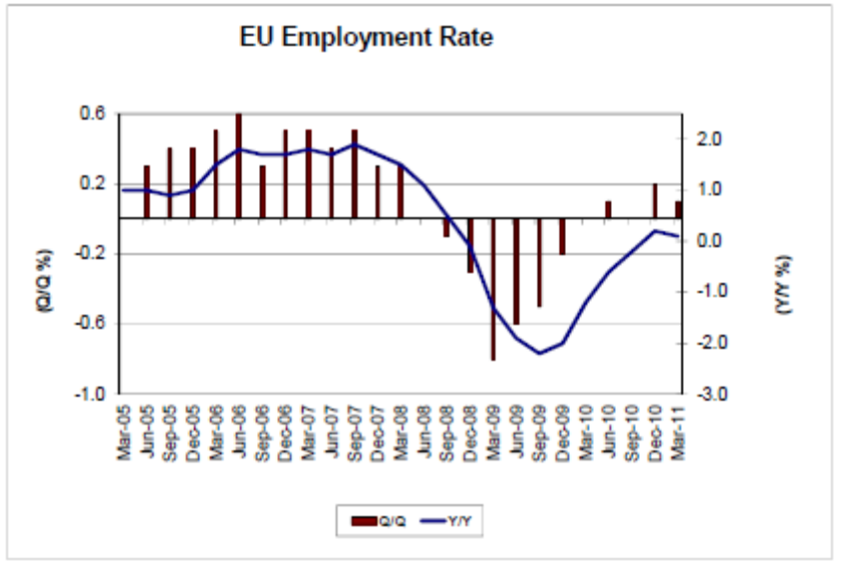
Austerity seems to be taking its toll in the euro zone.
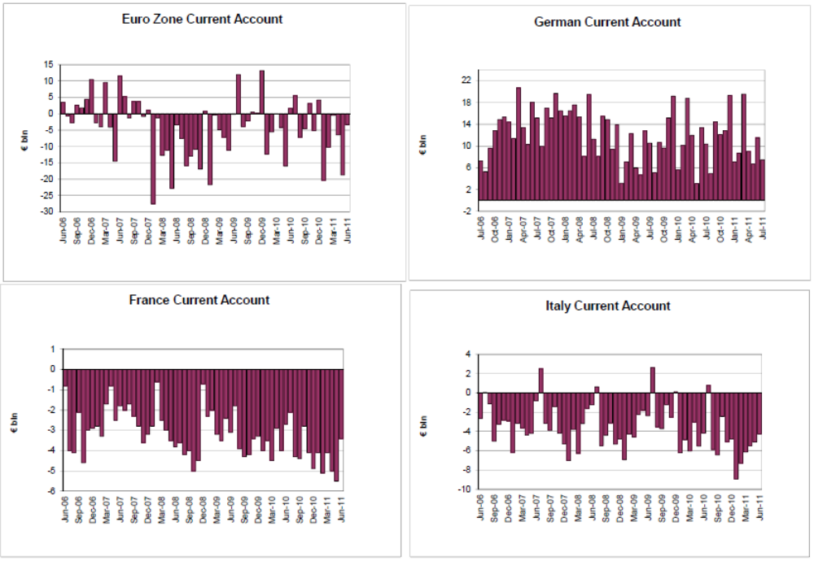
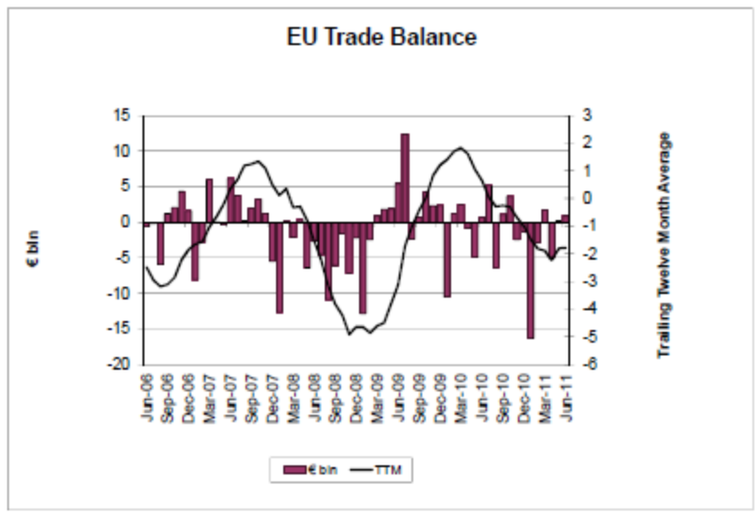
Seems Germany net exports to the rest of the euro zone while overall the euro zone trade balance is about flat over time.
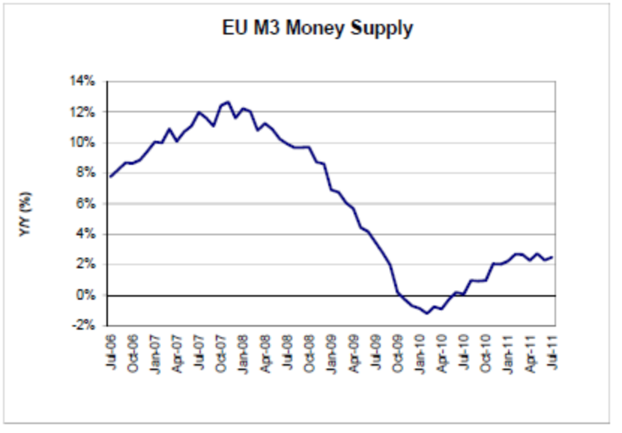
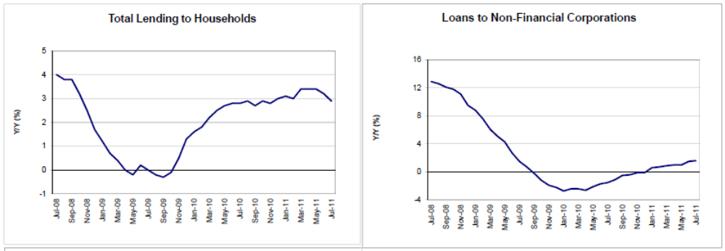
This could be showing loan growth low and flattening as regional credit issues bite.

